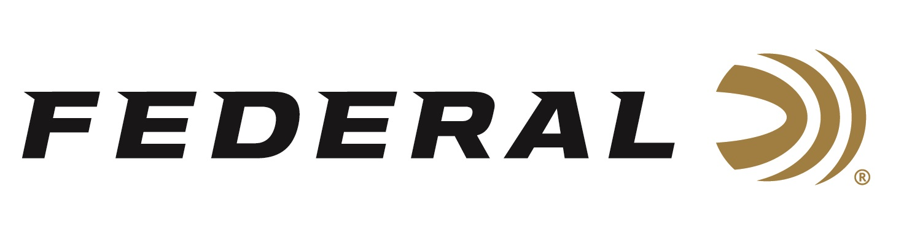

FOR IMMEDIATE RELEASE

Centennial Celebration on “It’s Federal Season” Podcast

ANOKA, Minnesota – June 16, 2022 – Duluth Pack CEO Tom Sega sits down with Federal’s President Jason Vanderbrink and V.P. of Marketing Jason Nash to discuss Federal’s 100th Anniversary. The conversation includes an in-depth look at the company’s early beginnings, its founders, pivotal moments in company history, and the early methods of building and selling the products that separated Federal from its competition.

Episode #36 “Centennial Celebration”
https://www.federalpremium.com/this-is-federal/podcast/

“It is amazing to look back at 100 years of this company and not be humbled by all the dedicated people who gave their talents to build Federal up to its #1 position today,” stated Jason Vanderbrink, President of Federal Ammunition. “It’s a great story I get to tell and enjoyed the conversation with Duluth Pack’s Tom Sega, a good friend, who also leads a Minnesota mainstay that has been in operation for 140 years.”

In the Tech Talk segment, the conversation switches to products and the innovations that have defined and continue to demonstrate why Federal is the world’s ammunition leader. To finish the podcast, Jason Nash talks with Kassie Mackenthun from the Anoka County Historical Society about a new exhibit opening to the public on July 9 at the ACHS.

For this episode, besides listening on the Federal Premium website or Talk North podcast network, you can also subscribe to Federal Ammunition’s YouTube channel (https://www.youtube.com/user/federalpremiumammo) and tune in for the discussion.

Federal Ammunition can be found at dealers nationwide or purchased online direct from Federal. For more information on all products from Federal or to shop online, visit www.federalpremium.com.

Press Release Contact: JJ Reich
Senior Manager – Press Relations
E-mail: VistaPressroom@VistaOutdoor.com

About Federal Ammunition
Federal, headquartered in Anoka, MN, is a brand of Vista Outdoor Inc., an outdoor sports and recreation company. From humble beginnings nestled among the lakes and woods of Minnesota, Federal Ammunition has evolved into one of the world's largest producers of sporting ammunition. Beginning in 1922, founding president, Charles L. Horn, paved the way for our success. Today, Federal carries on Horn's vision for quality products and service with the next generation of outdoorsmen and women. We maintain our position as experts in the science of ammunition production. Every day we manufacture products to enhance our customers' shooting experience while partnering with the conservation organizations that protect and support our outdoor heritage. We offer thousands of options in our Federal Premium and Federal® lines-it's what makes us the most complete ammunition company in the business and provides our customers with a choice no matter their pursuit.

